Module-1 AWS- L3

Submitted by – C.Madhavi

Submitted to – Vikul mentor

Date of submission- 24/09/2024

3. L3 - Launch AWS EC2 Ubuntu Instance and configure the Security Group - Inbound Rule: 8080. Justify the usage of Inbound Rules.

Step1: Login to your AWS account and open EC2.

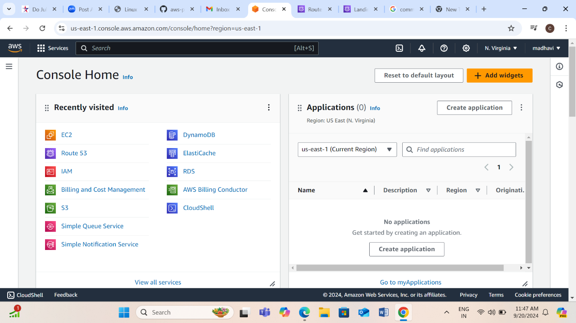

Step2: Click on Instances for creating new server.

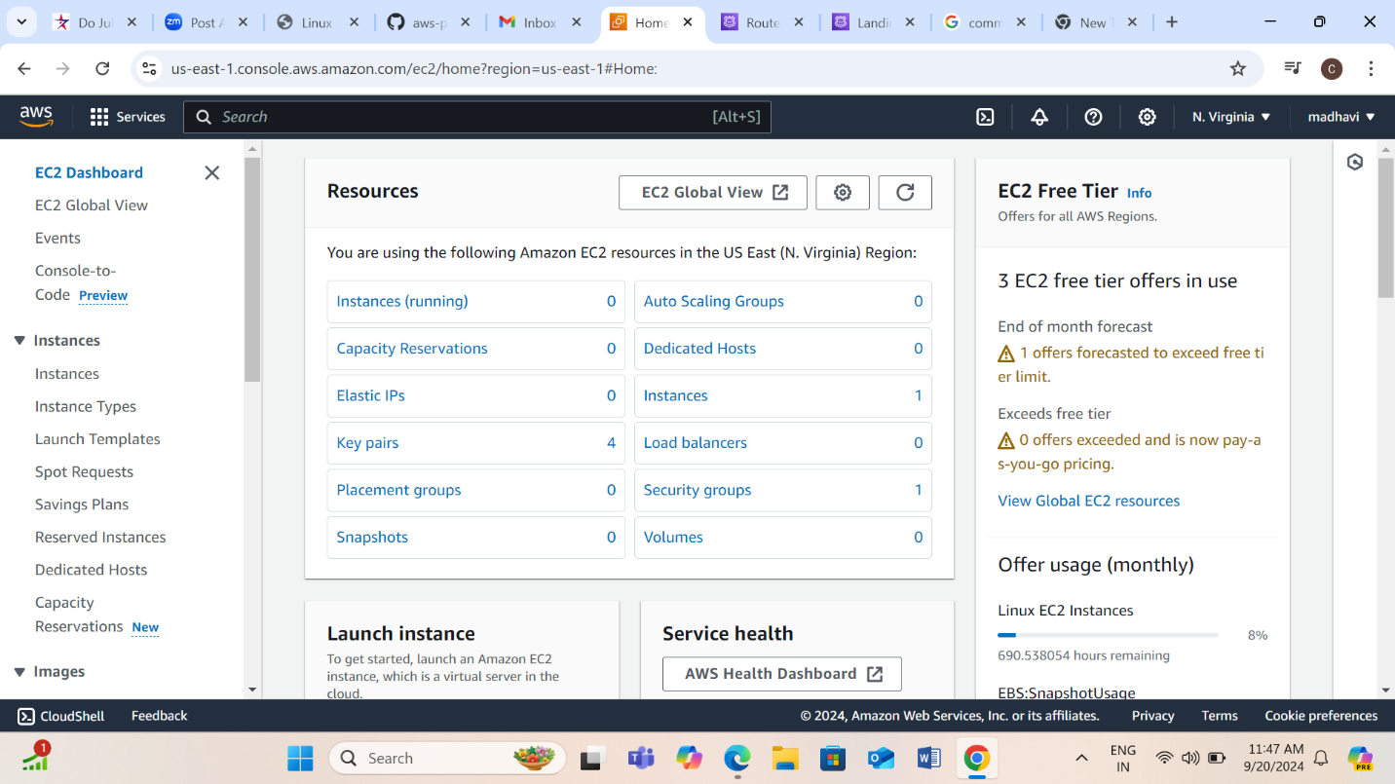

Step3: Click on Launch Instances.

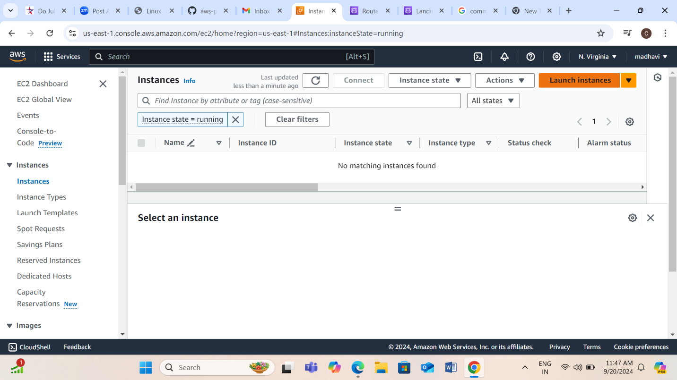

Step4: Give name to the instance and mention number of servers you want to create.

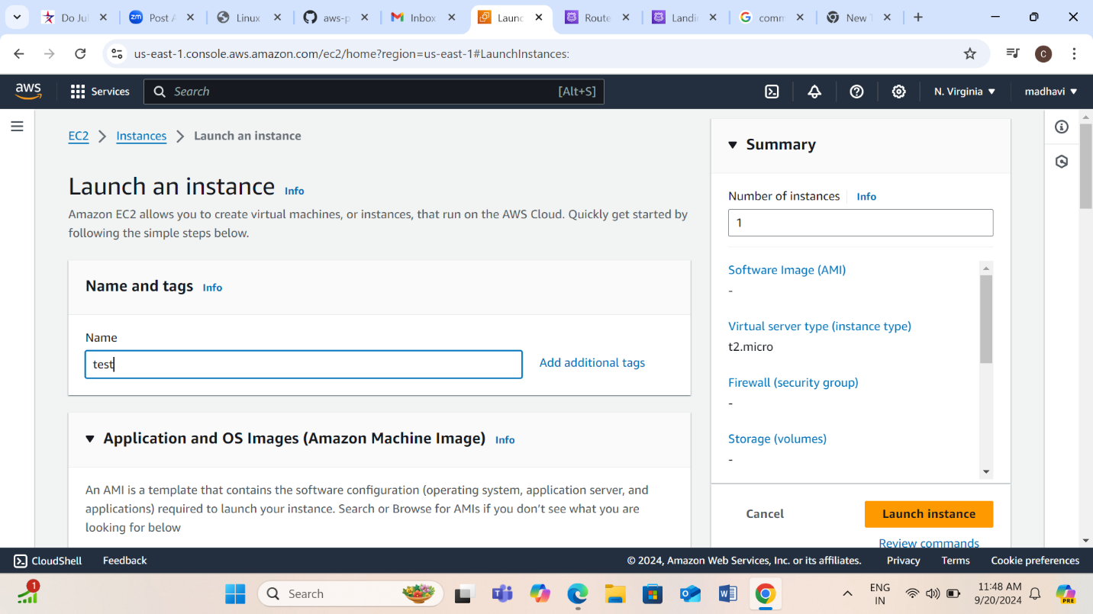

Step5: Select the UBUNTU instance, here I’m going with free tier.

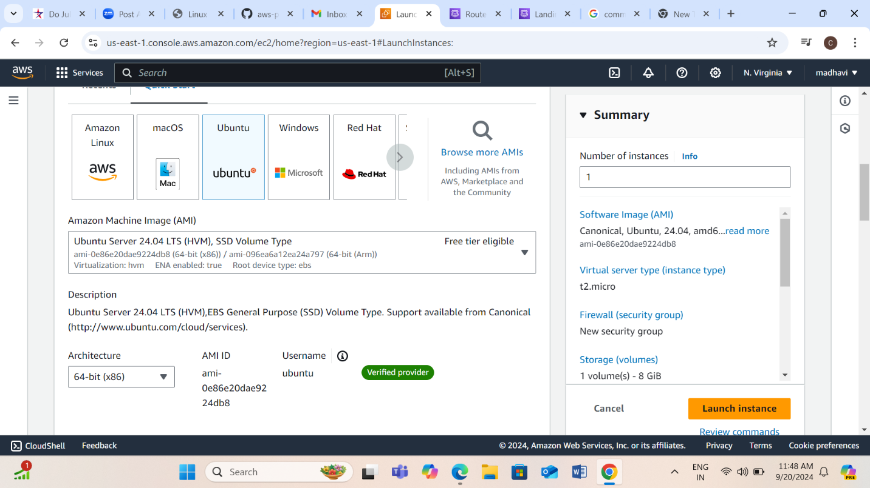

Step6: Select the Instance type, I’m using t2.micro.

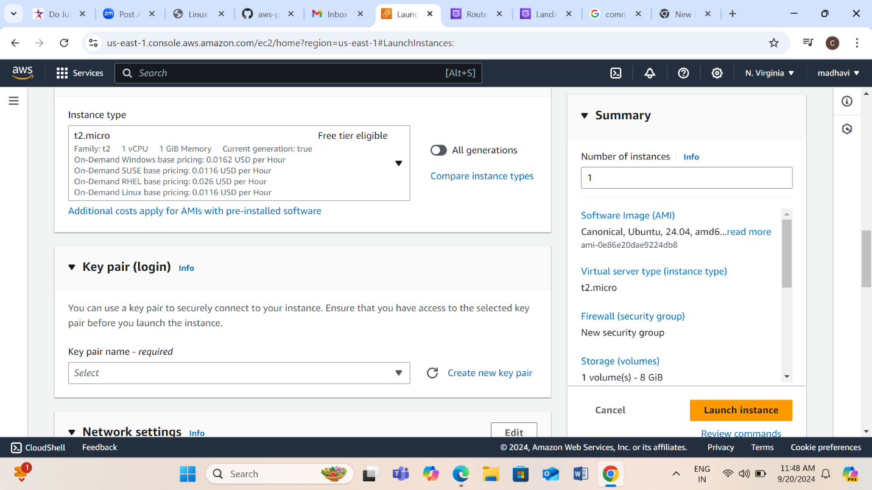

Step7: Select the key pair.

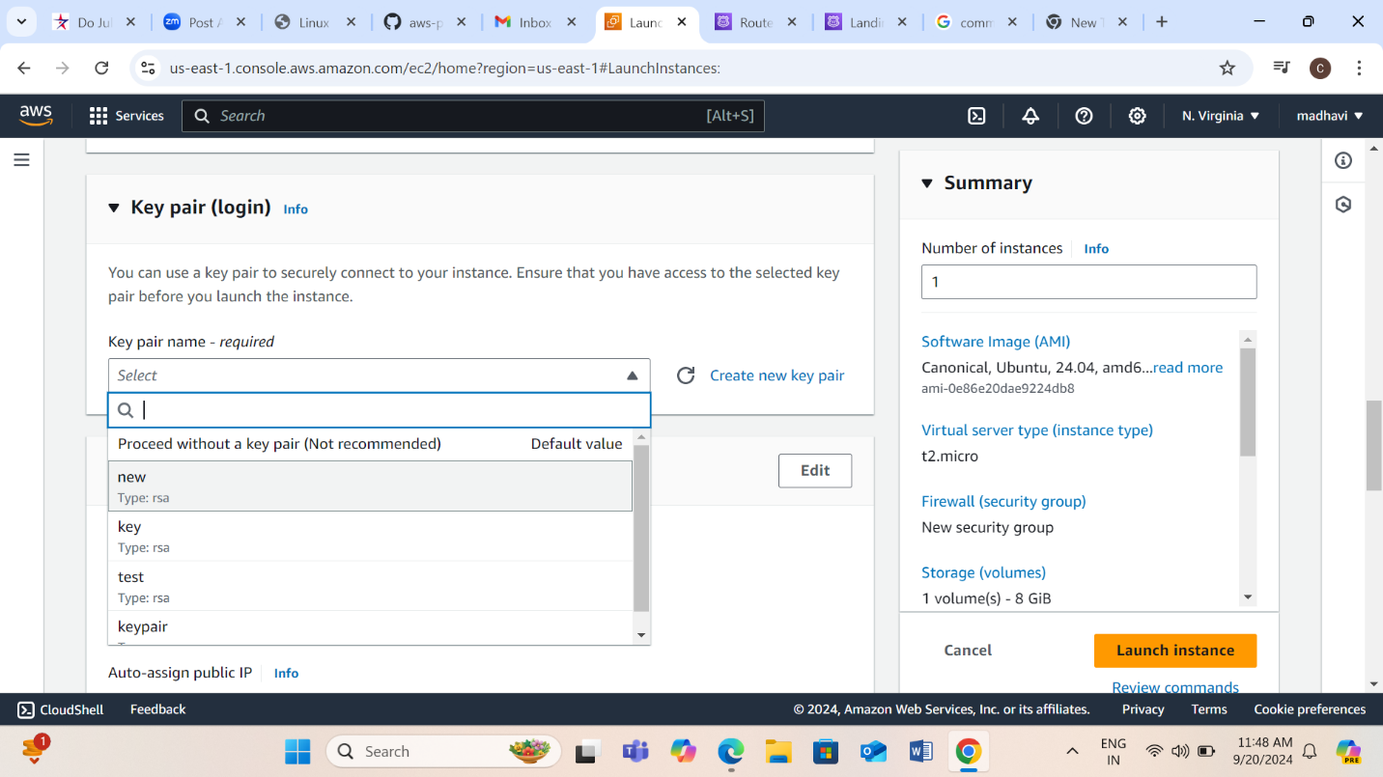

Step8: Let the security groups be as default, we can edit them after creating the server.

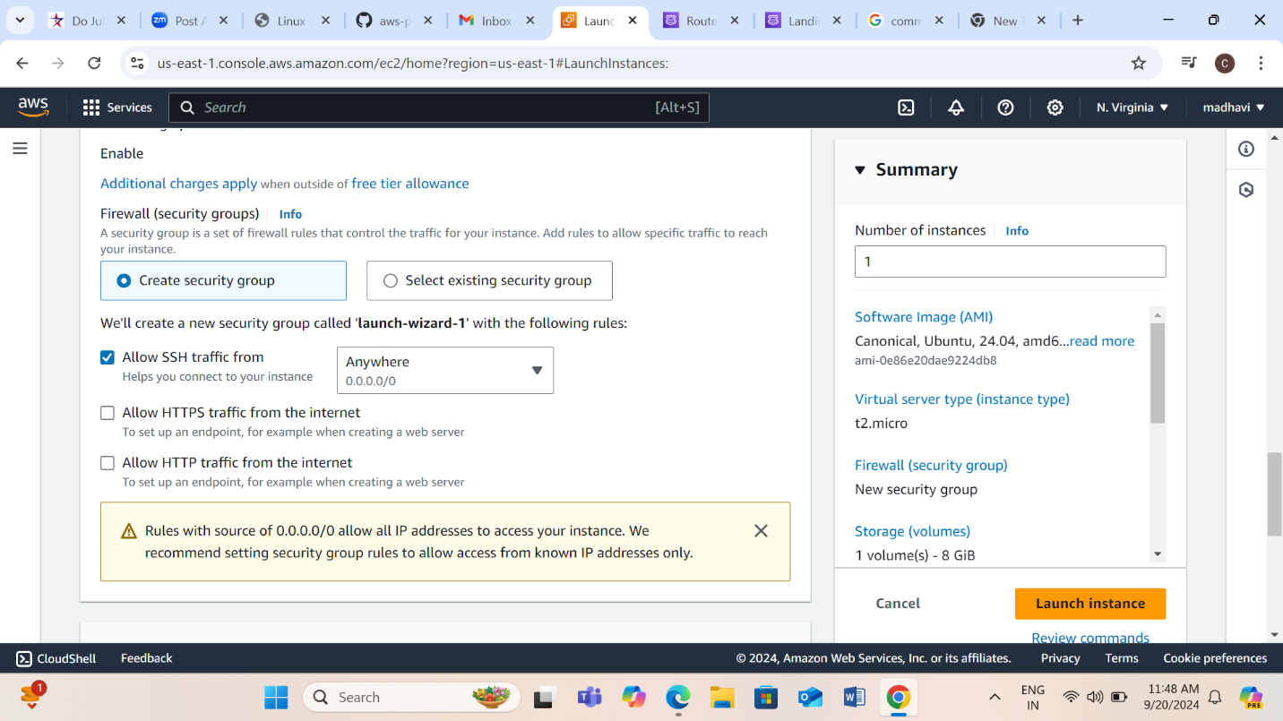

Step9: Configure the required storage volume and click on Launch Instance.

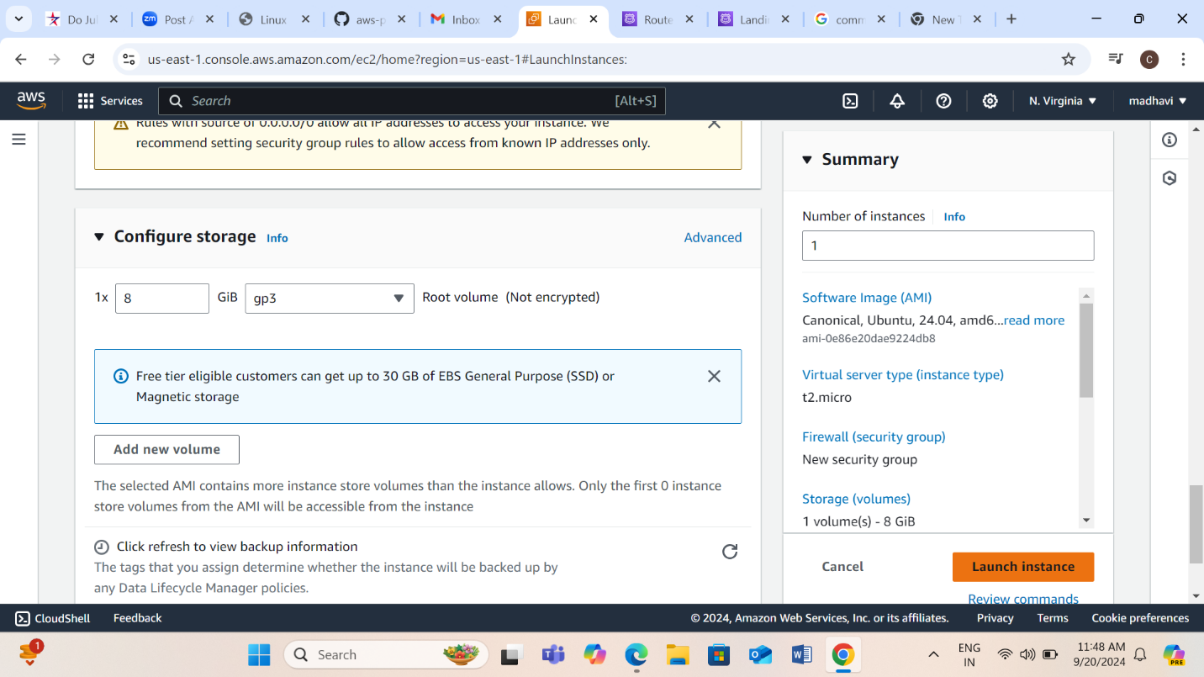

Step10: Instance launched successfully.

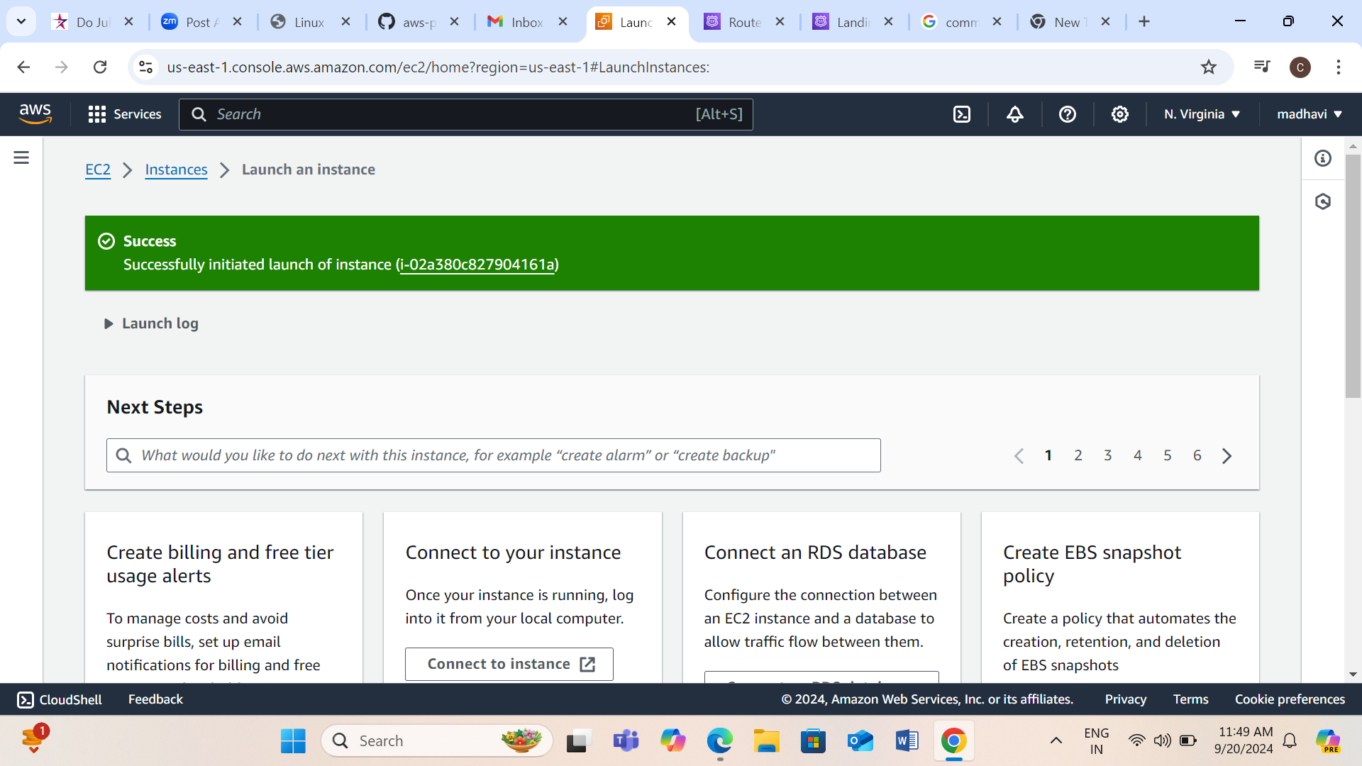

Step11: Go to Instances and open the server.

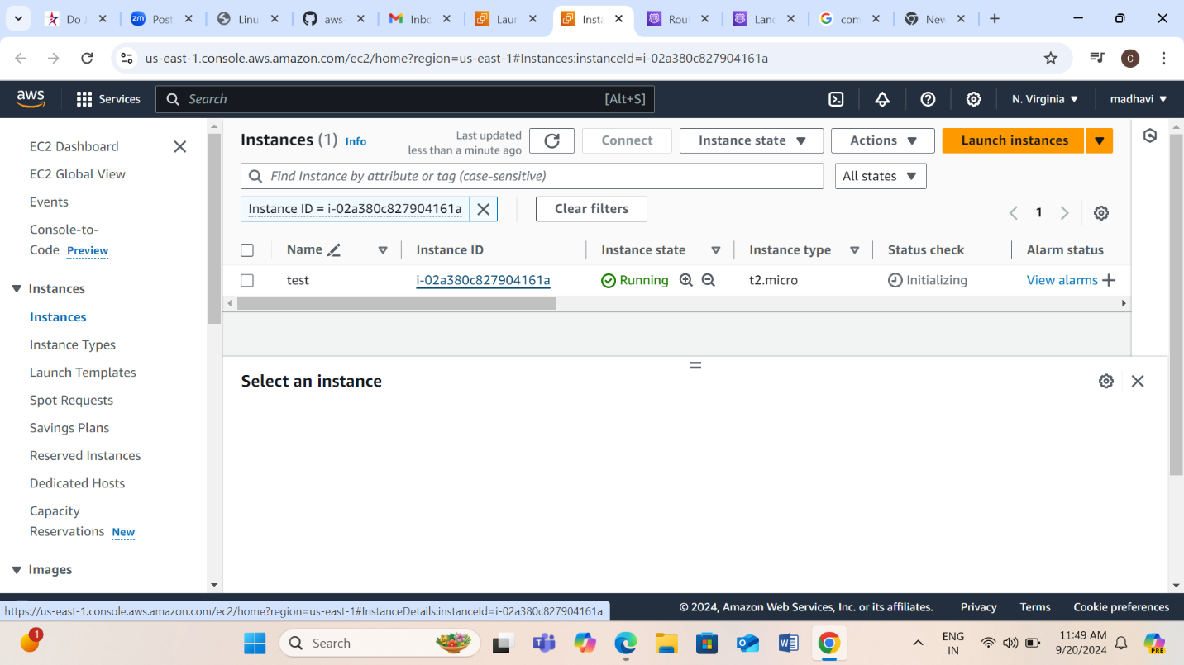

Step12: Here you can see the details for the server we created.

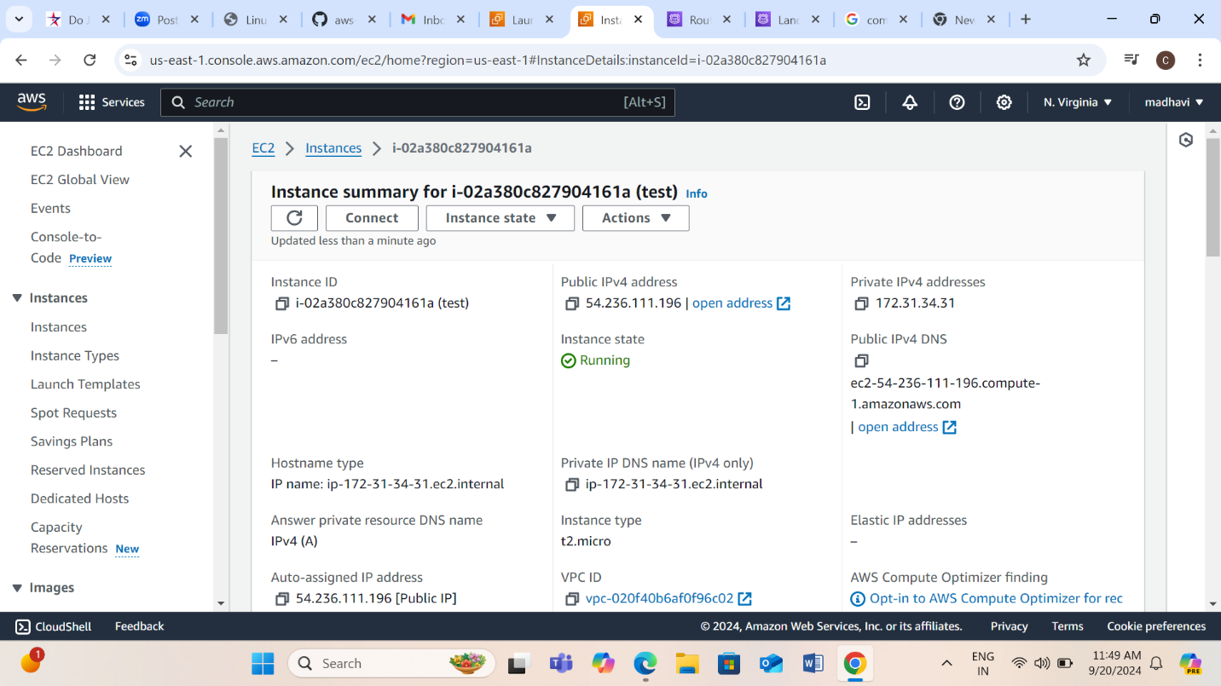

Step13: Go to the security section and click on the security groups link.

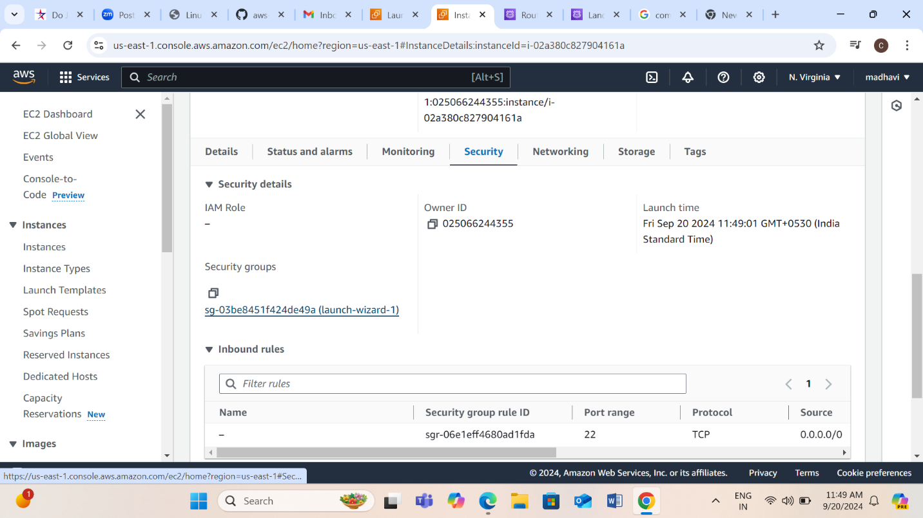

Step14: Details of the security groups are shown here.

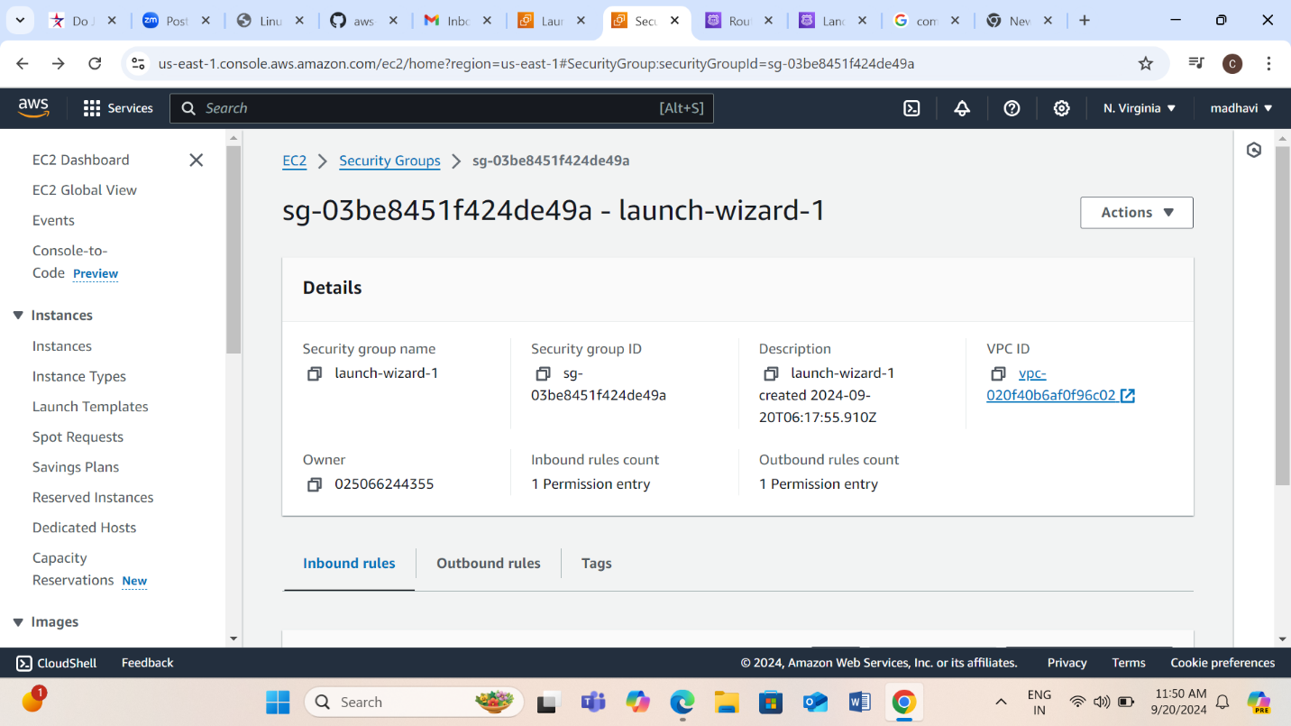

Step15: Go to Inbound rules section and click on edit inbound rules.

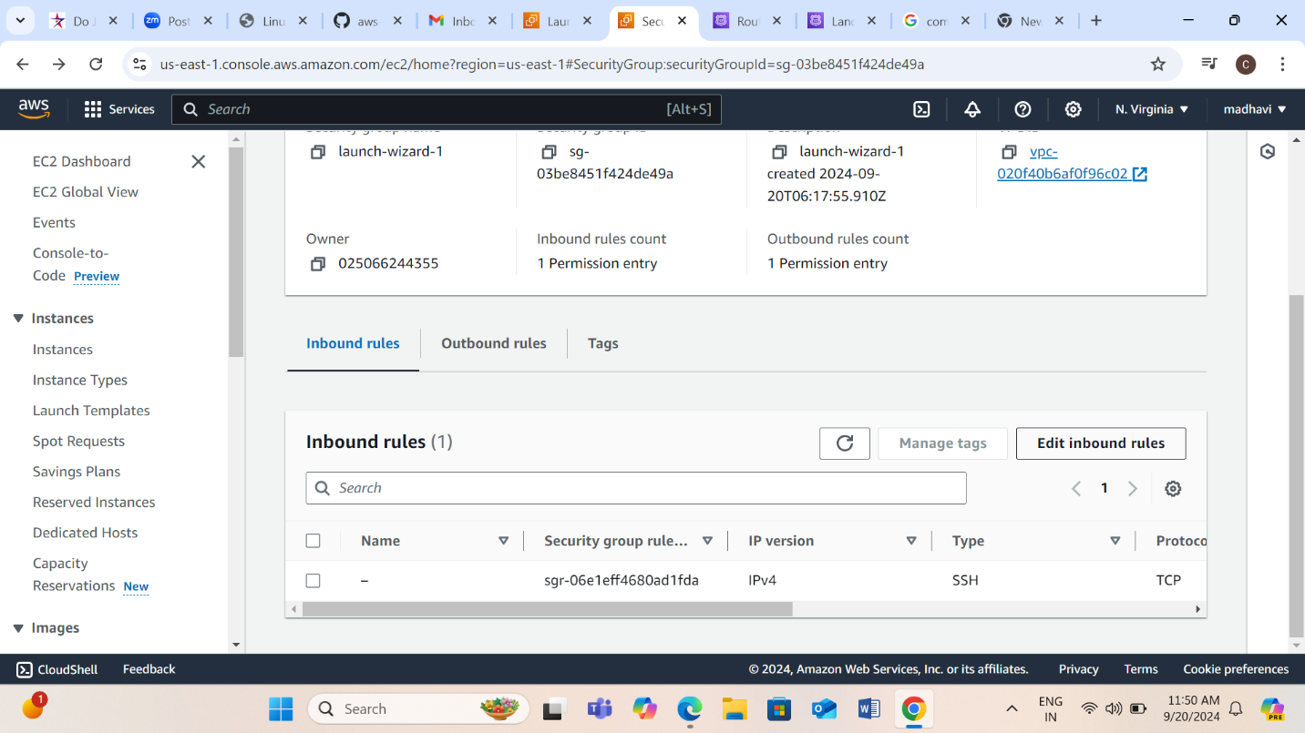

Step16: Click on add rule to configure 8080 inbound rule.

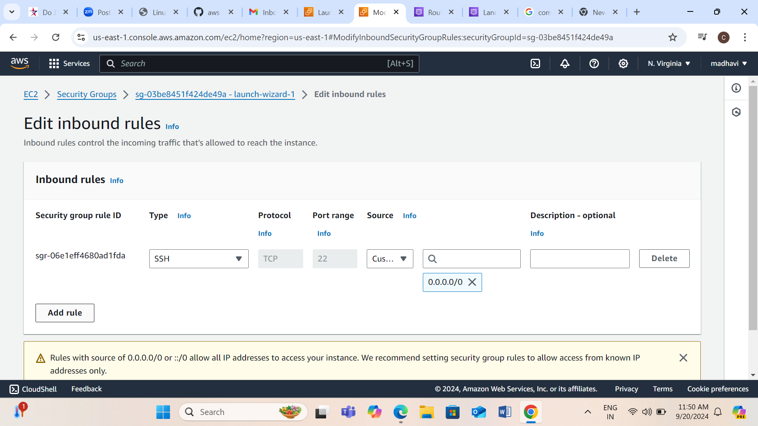

Step17: Select the custom TCP.

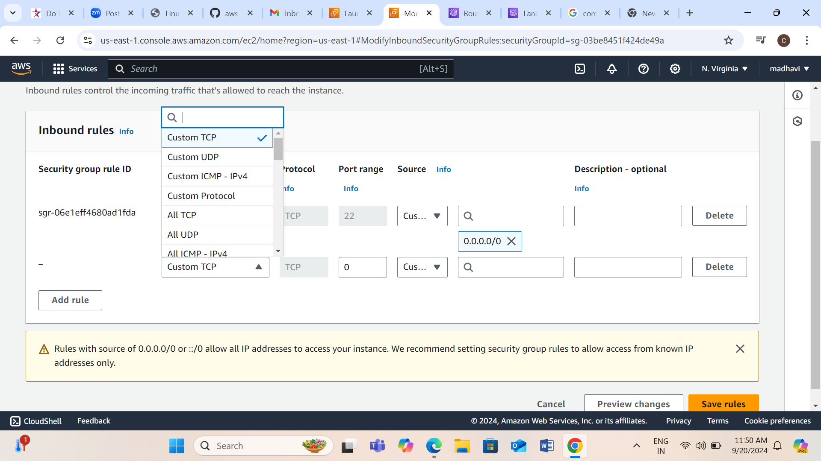

Step18: Configure the port range as 8080 and select the source as anywhere-IPV4.

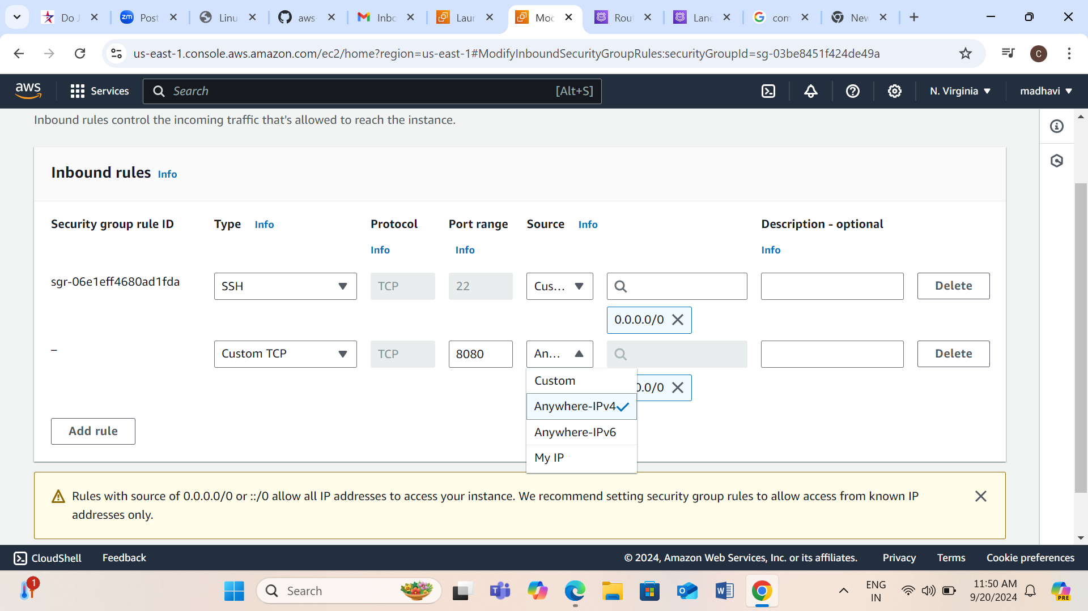

Step19: Here we configured the Inbound rule as 8080 that means we are allowing 8080 port(tomcat) to access the server.

Inbound Rules: It is the rule that we can configure who can access the server. By adding the port number, we are allowing that particular service or user to access the Instance. You can set rules that who can access and who shouldn’t access the Instance. This helps to avoid unwanted users (or) services from accessing it.

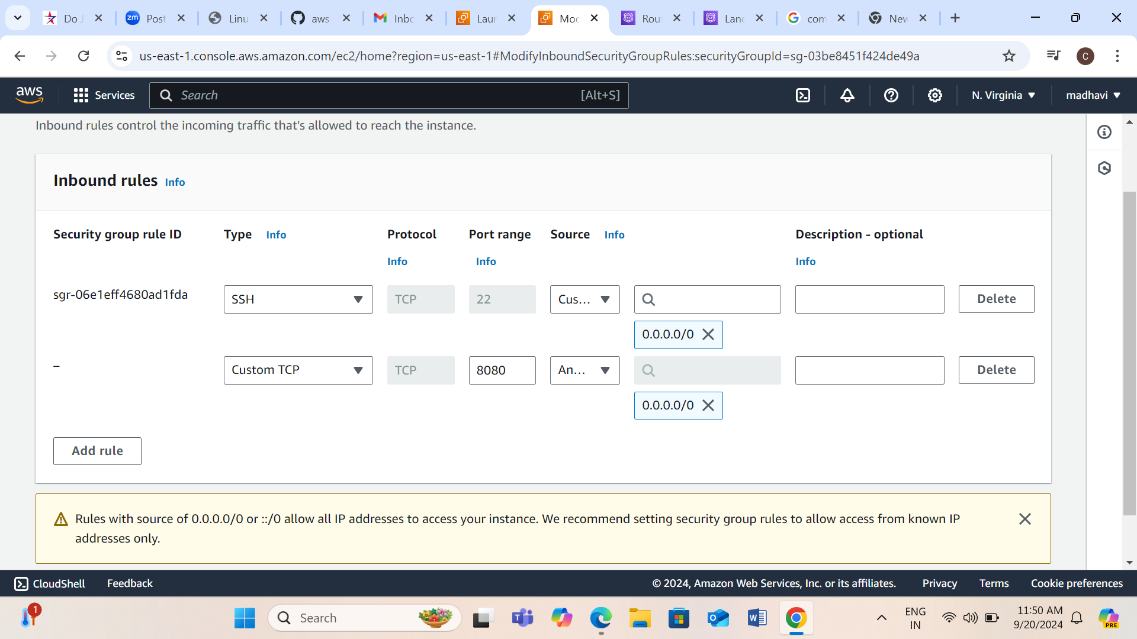

Step20: Click on save rules.

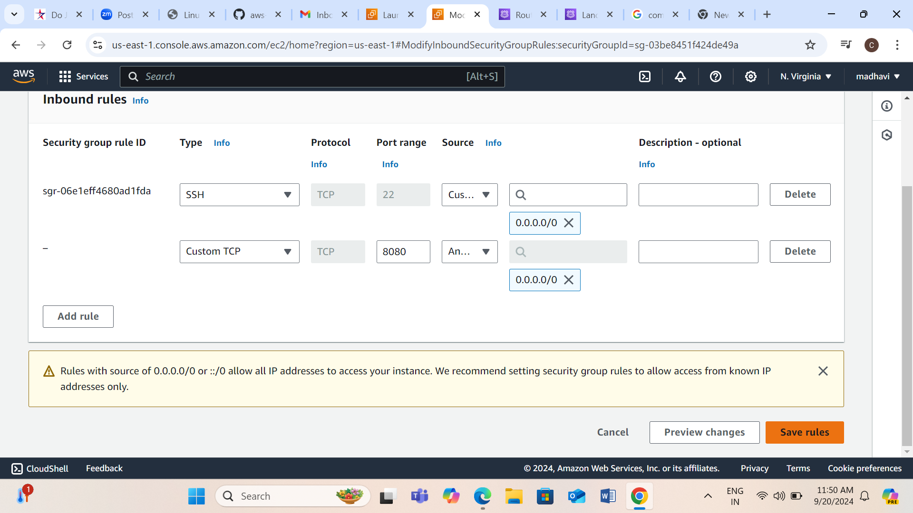

Step21: Inbound security group rules modified successfully.

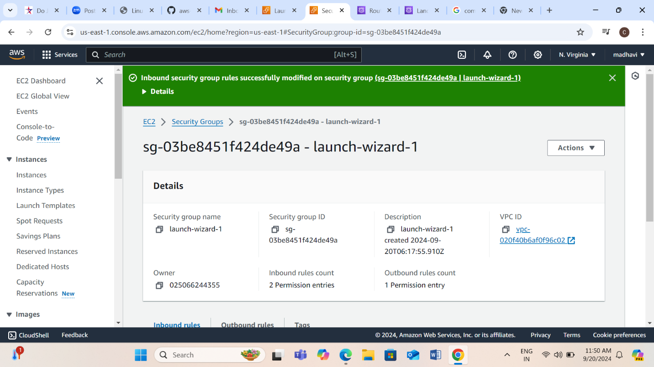

Step22: Inbound rule as 8080 is added here.

